Tutorial upload as part of the assessment.

Student Name: Ojaswi Shrestha

University Id: c7466889

Tutorial Tasks Assignment Title: Design/Implementation

Note: Submit evidence showing the process and workings for your weekly tutorial Apex tasks.

Take screenshots showing clearly:

1. Student id in Apex account
2. Apex 5 – university www address
3. Time and date on your machine

E.g.

1

2

3

Important note: We expect to see all Recent activities in the Apex account. If these are blank or older then expected during the semester run (e.g. no activity or no activity for a few weeks) we will assume that your code is result of poor practice, as it is impossible to write a fully functional code without a practice.

E.g. Screenshot of SQL Workshop Home page (include as many as you need to evidence your 12 weeks engagement).

Screenshot of SQL scripts environment (include as many as you need to evidence your 12 weeks engagement)

Screenshot of SQL Commands – SAVED scripts (include as many as you need to evidence your 12 weeks engagement) – this is optional, if not used

**Tasks: Here submit evidence of completing the weekly tutorial as per the instructions in the Module Handbook – Assessment section.**

Note that here you will show screenshots with same key info as above, just evidence that tasks have been completed and process of how it was done, as per specified in the task.

You can copy the task here from the Module handbook and provide your solution below, for each task.

**Exercise 1:** How to uploada SQL script from your local file system

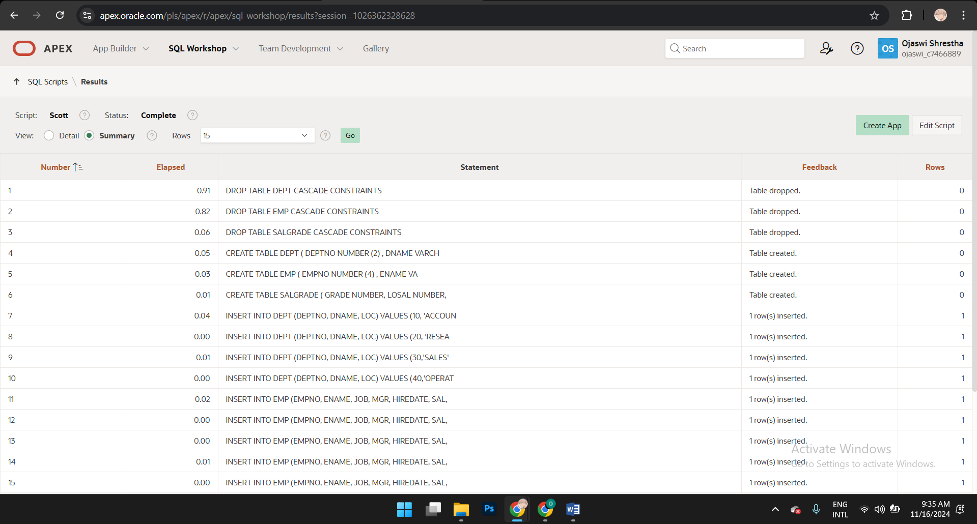

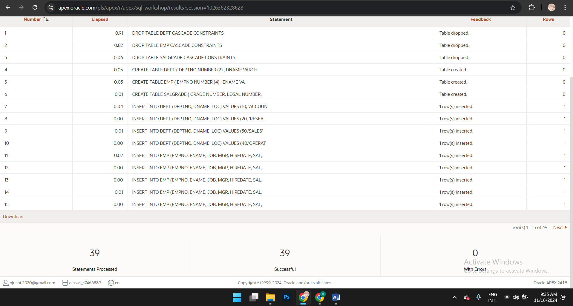

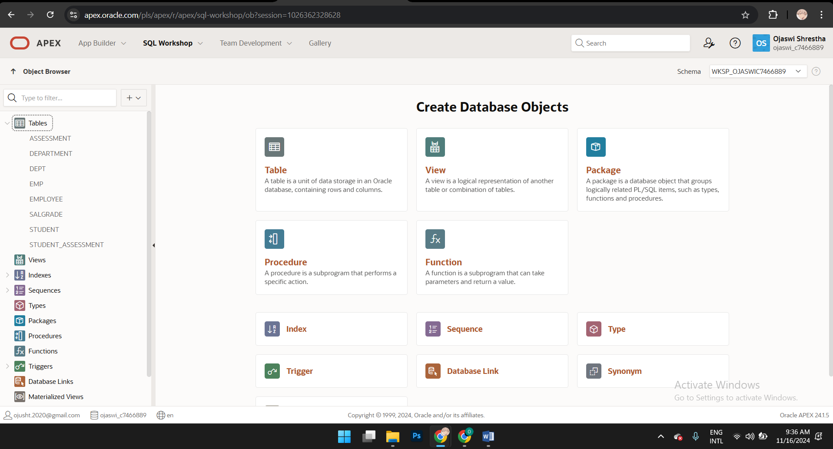 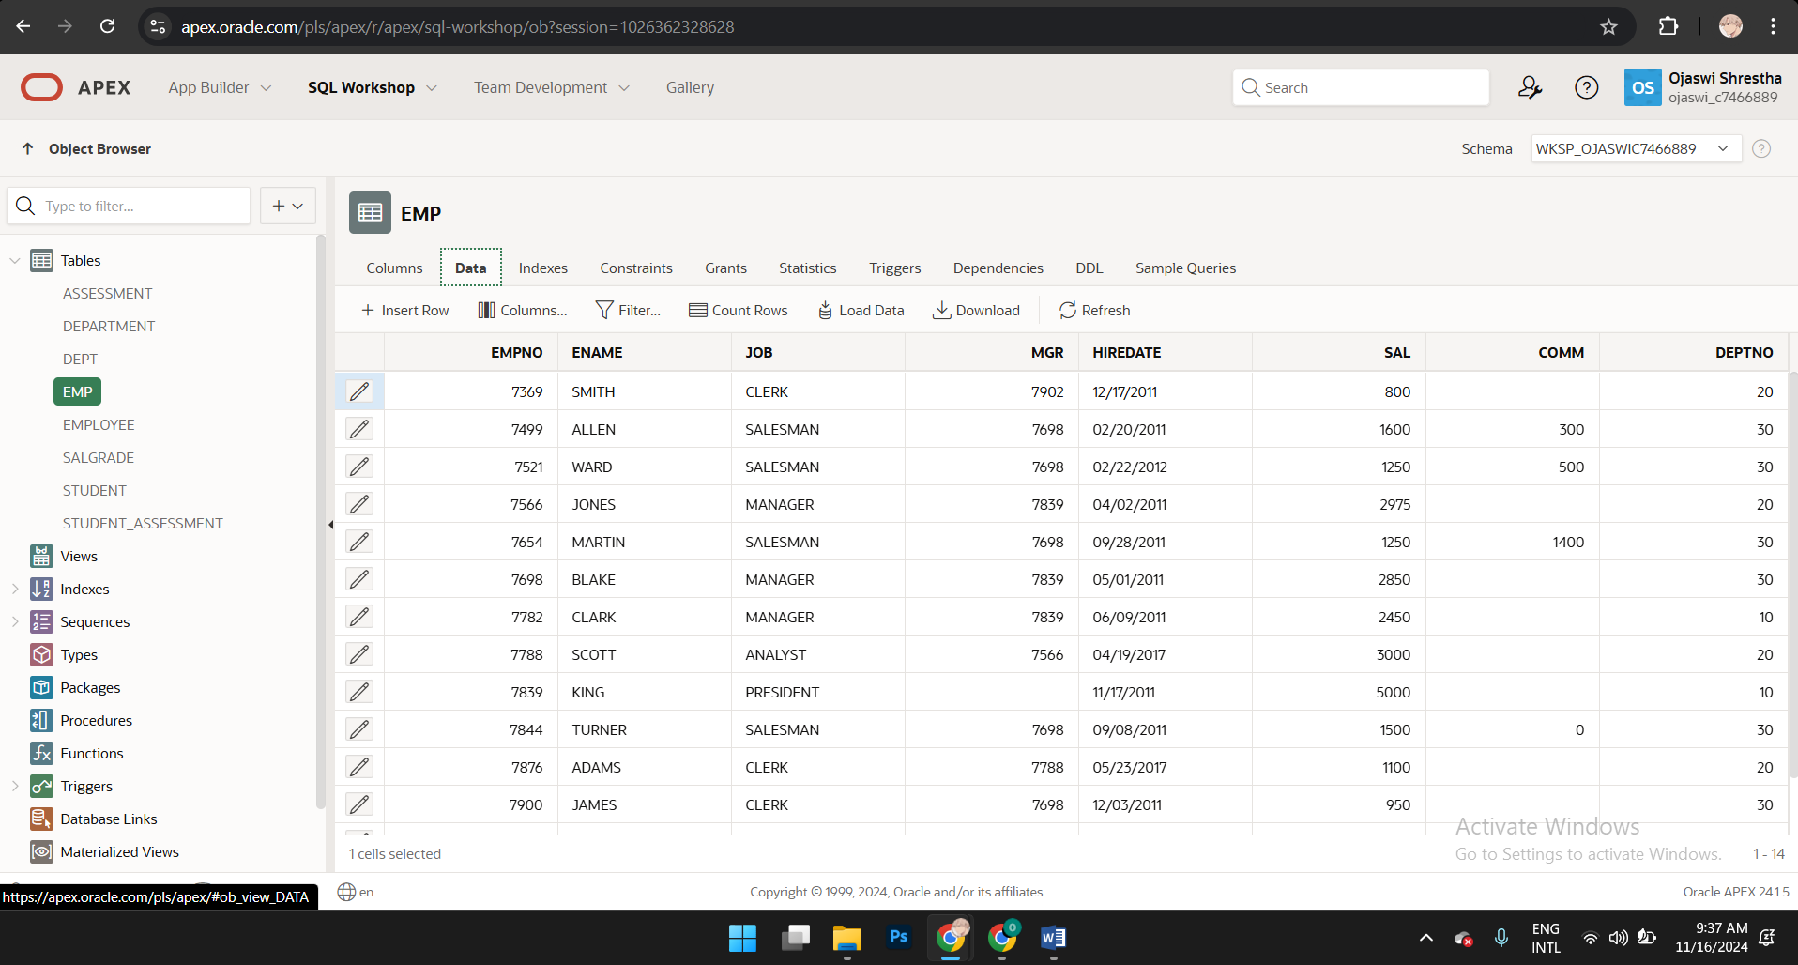

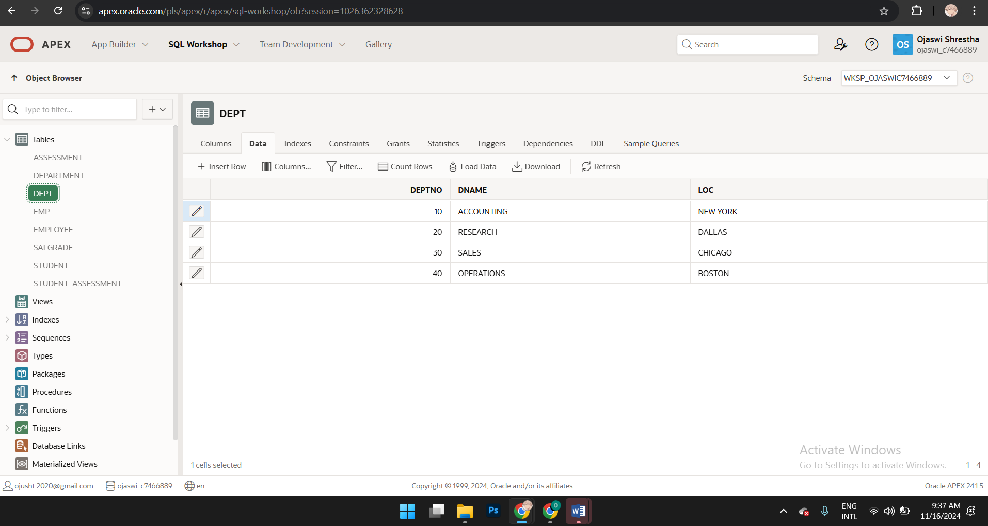

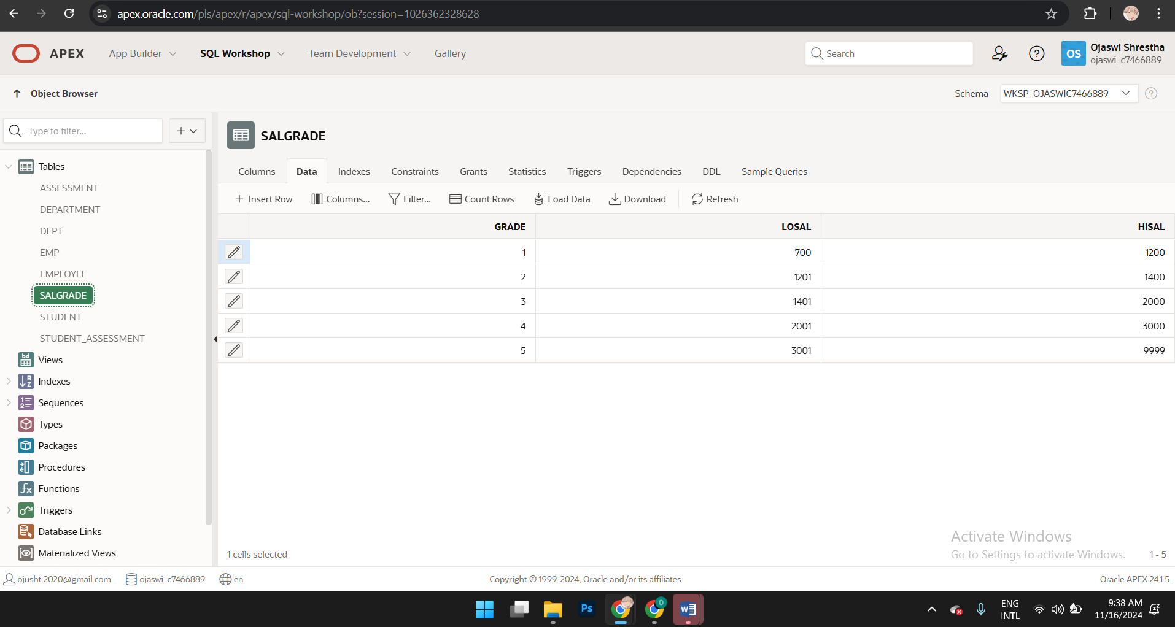

Why and when do we have to specify CASCADE CONSTRAINTS after the table name?

When a table has constraints (e.g., primary keys or unique constraints) that are referenced by foreign keys in other tables, simply using DROP TABLE table_name; will result in an error. This is because the database prevents you from deleting a table if doing so would leave other tables with "orphaned" foreign key references. Adding CASCADE CONSTRAINTS tells the database to automatically drop any constrain

CASCADE CONSTRAINTS is used when: Deleting a table with foreign keys referenced by other tables. For example, if you want to drop a DEPARTMENT table that is referenced by a foreign key in the EMPLOYEE table. Dropping multiple interdependent tables. If tables reference each other with foreign keys, dropping them with CASCADE CONSTRAINTS can avoid the need to manually drop constraints in advance.

**Exercise 2: Create a table called *department***

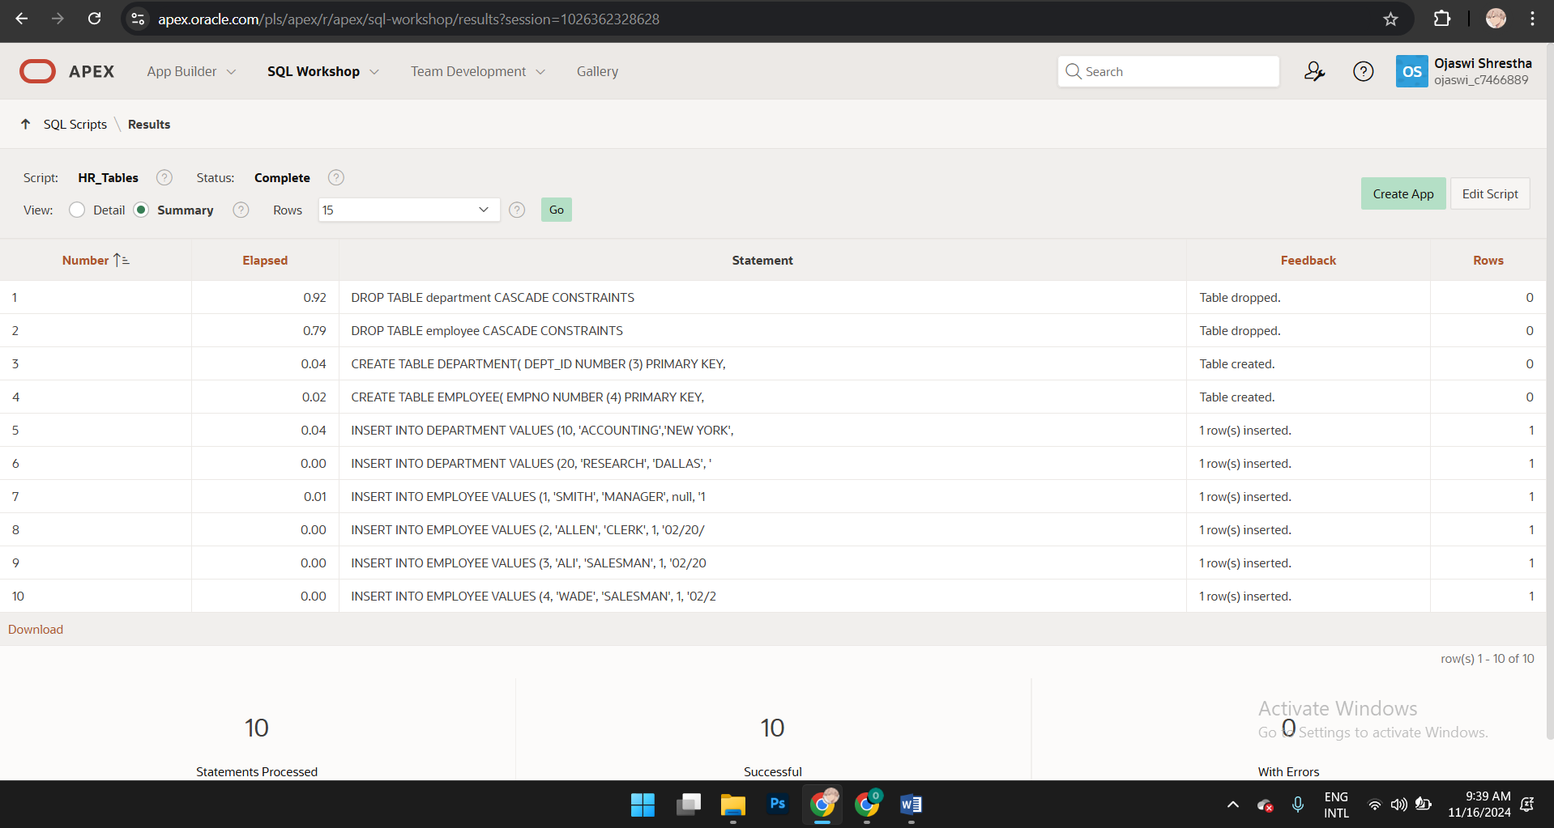

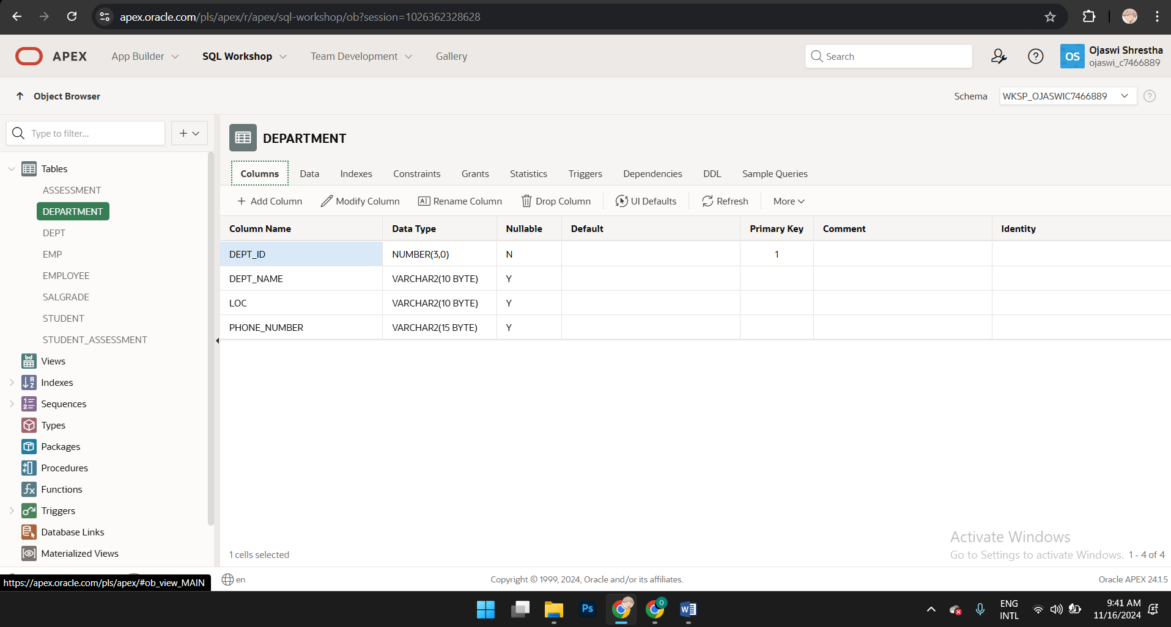

**Exercise 3: Insert data into the DEPARTMENT table**



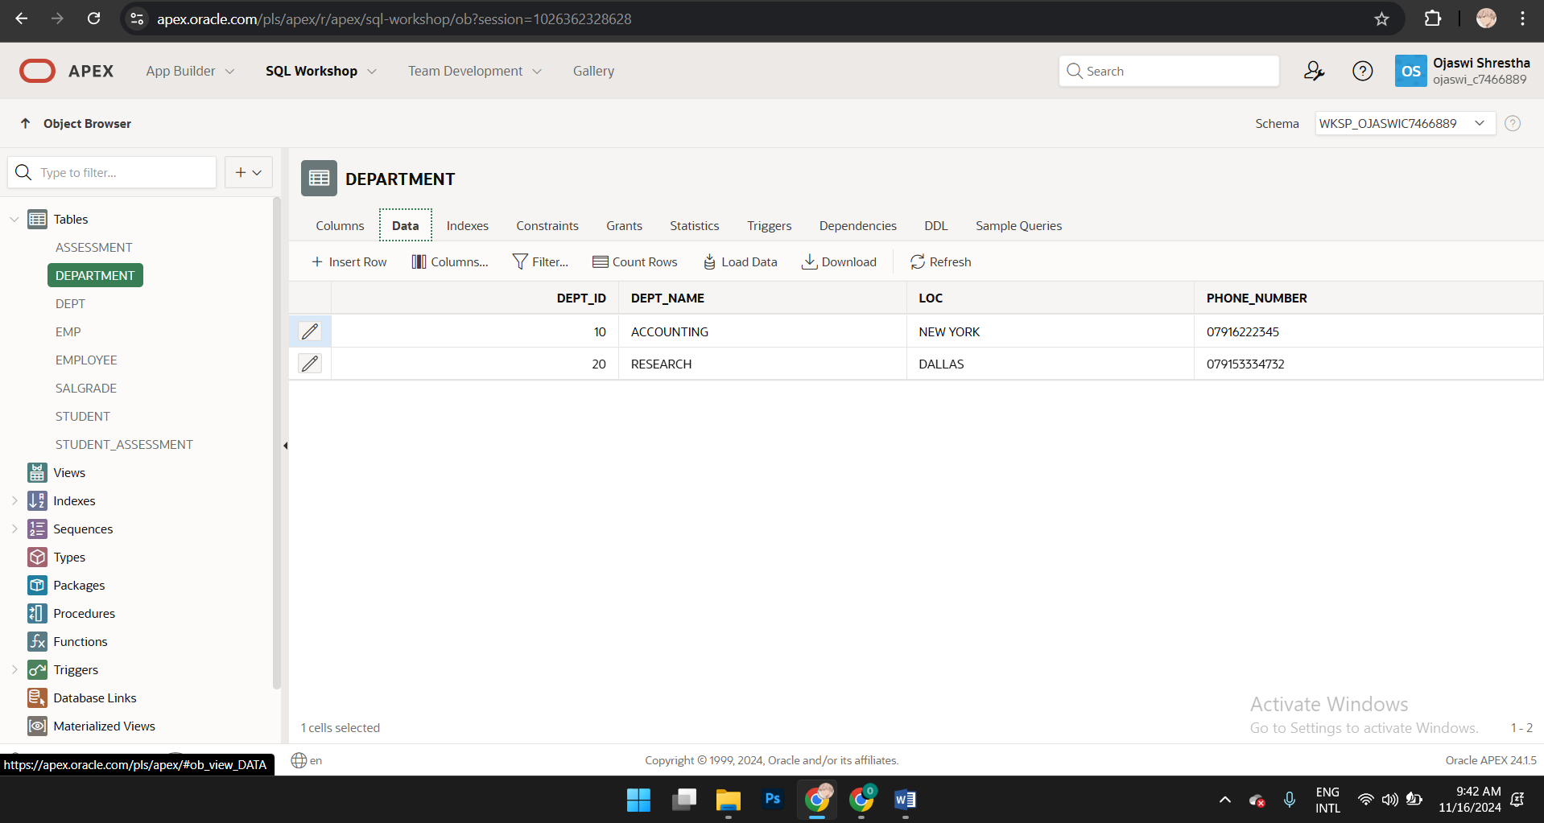

**Exercise 4: Create a table called EMPLOYEE  
**

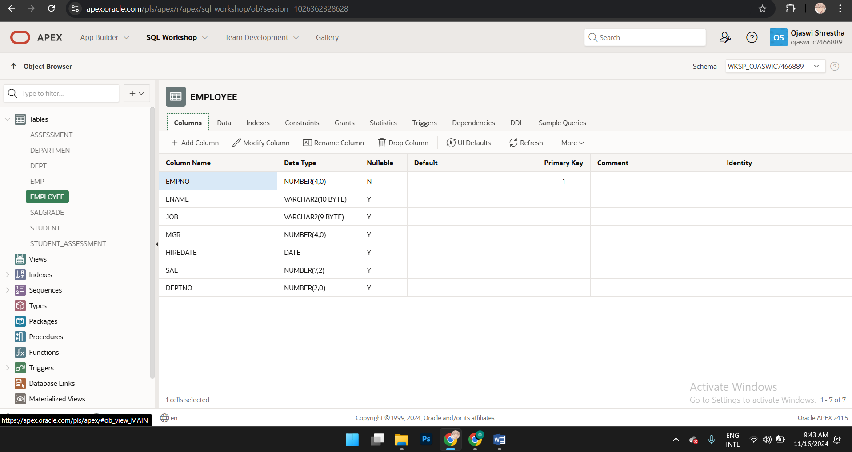

**Exercise 5: Insert data into the table.**



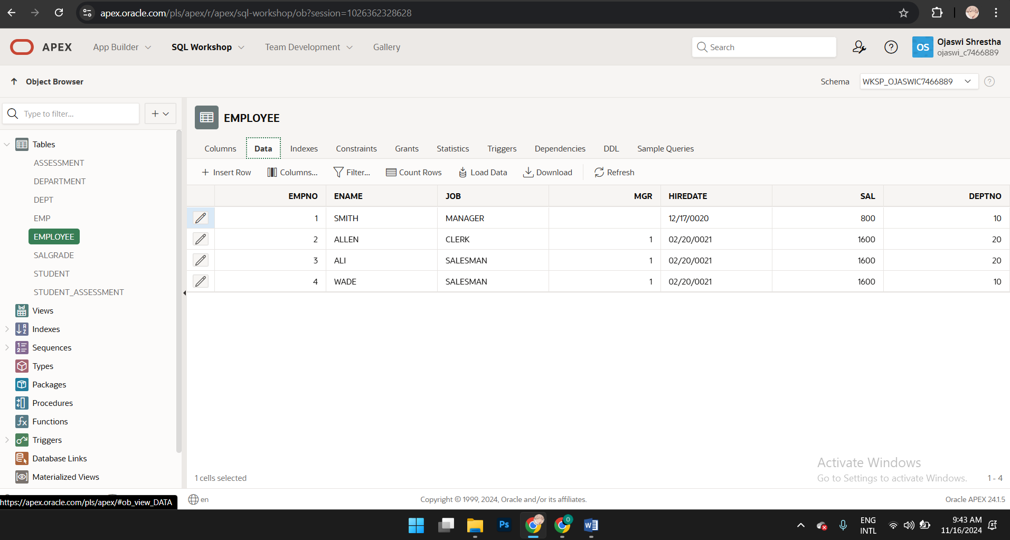

**Test 1: Find errors in the code and correct it:**

DROP TABLE student CASCADE CONSTRAINTS;

DROP TABLE location CASCADE CONSTRAINTS;

CREATE TABLE location(

Location_id NUMBER (3) PRIMARY KEY,

Location_name VARCHAR2(30) UNIQUE

);

CREATE TABLE student(

Student_id NUMBER(2) PRIMARY KEY,

Name VARCHAR2(20),

Address VARCHAR2(30),

Gender VARCHAR2(1) ,

Location_number NUMBER(3) REFERENCES location(Location_id),

CHECK (Gender = 'M' or gender = 'F')

);

INSERT INTO location VALUES (1, 'Headingley Campus, Leeds');

INSERT INTO location VALUES (2, 'Civic Quarter, Leeds');

INSERT INTO location VALUES (3, 'Distance Learner, Leeds');

INSERT INTO student VALUES (1, 'Aiden Andrews', '1 The Avenue, 1AA AAA', 'M', 1);

INSERT INTO student VALUES (2, 'Billy Brag', '2 Bank Street, 2BB BBB', 'M', 2);

INSERT INTO student VALUES (3, 'Colin Chips', '3 Crescent Mews 3CC CCC', 'M', 3);

INSERT INTO student VALUES (4, 'Freida Julius', '4 The Drive, 4DD DDD', 'F', 3);

**Exercise 5: Running an SQL Command**

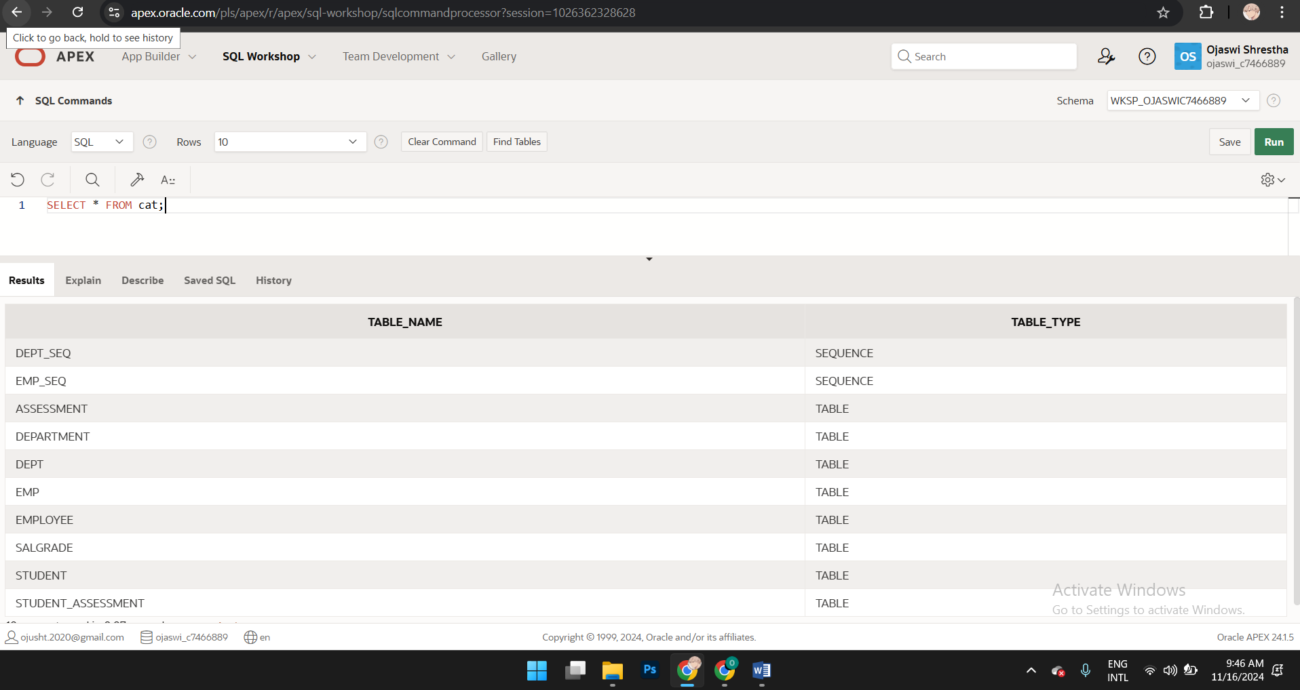

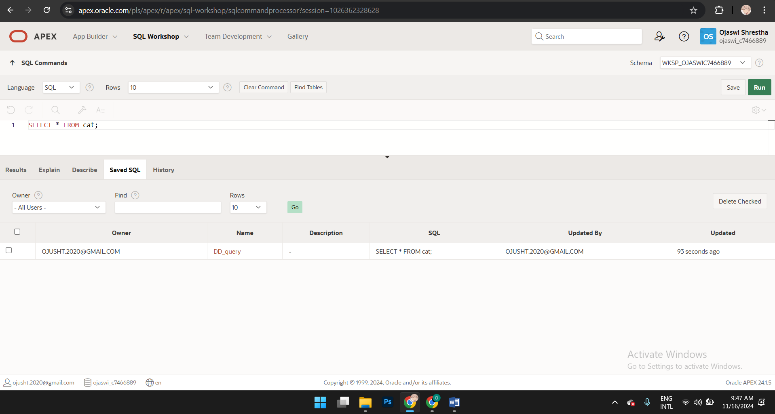

In ORACLE APEX CAT is a synonym for USER_CATALOG. It can also refer to a command that saves results to a database that is defined in the data sources (section of a project file).

No, it is not a table but rather a data dictionary.

**Exercise 6** To execute an SQL Command:

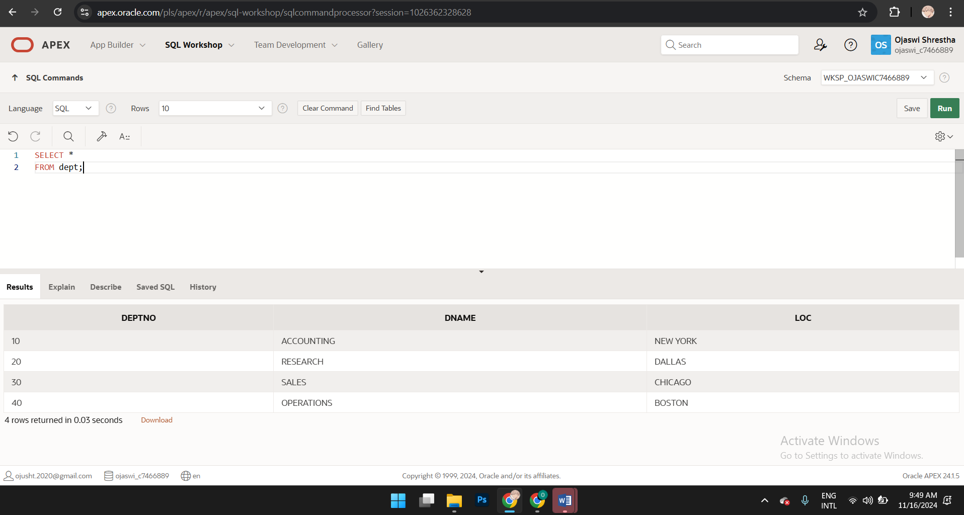**Exercise 7**

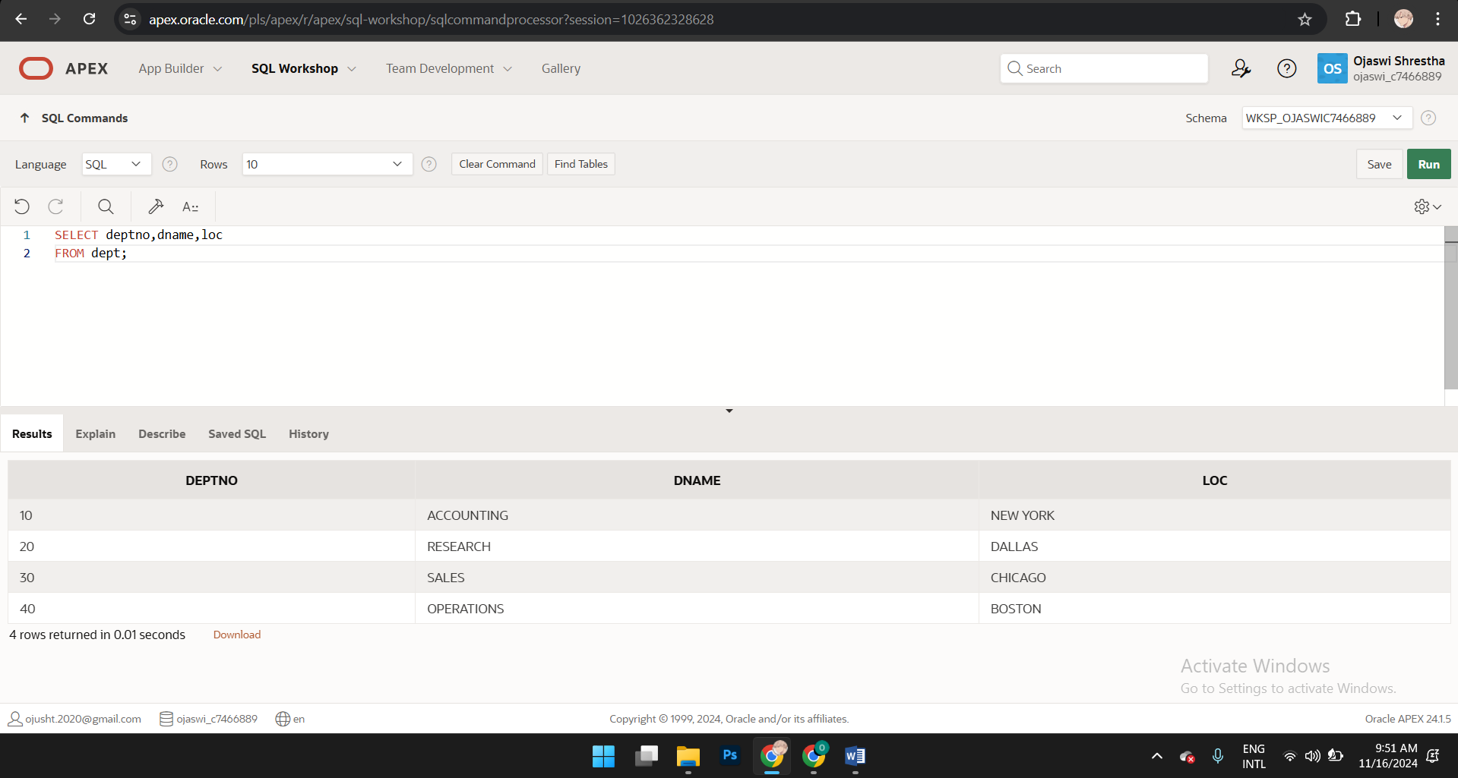

**Exercise 8** Write an SQL command to return data from the emp table. Save the script as **select2**.

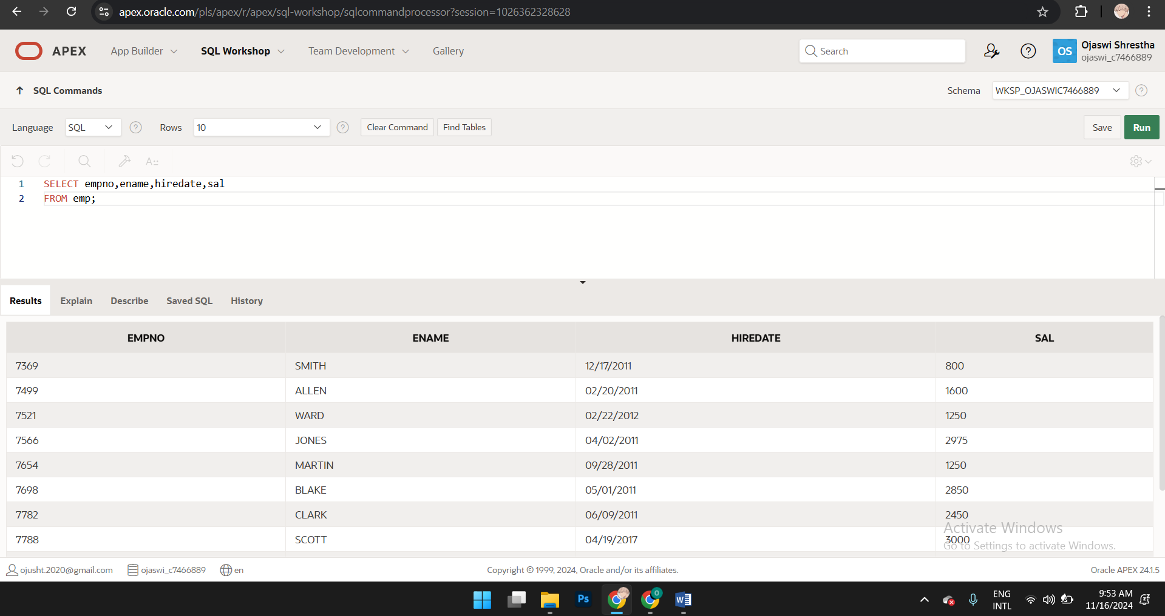

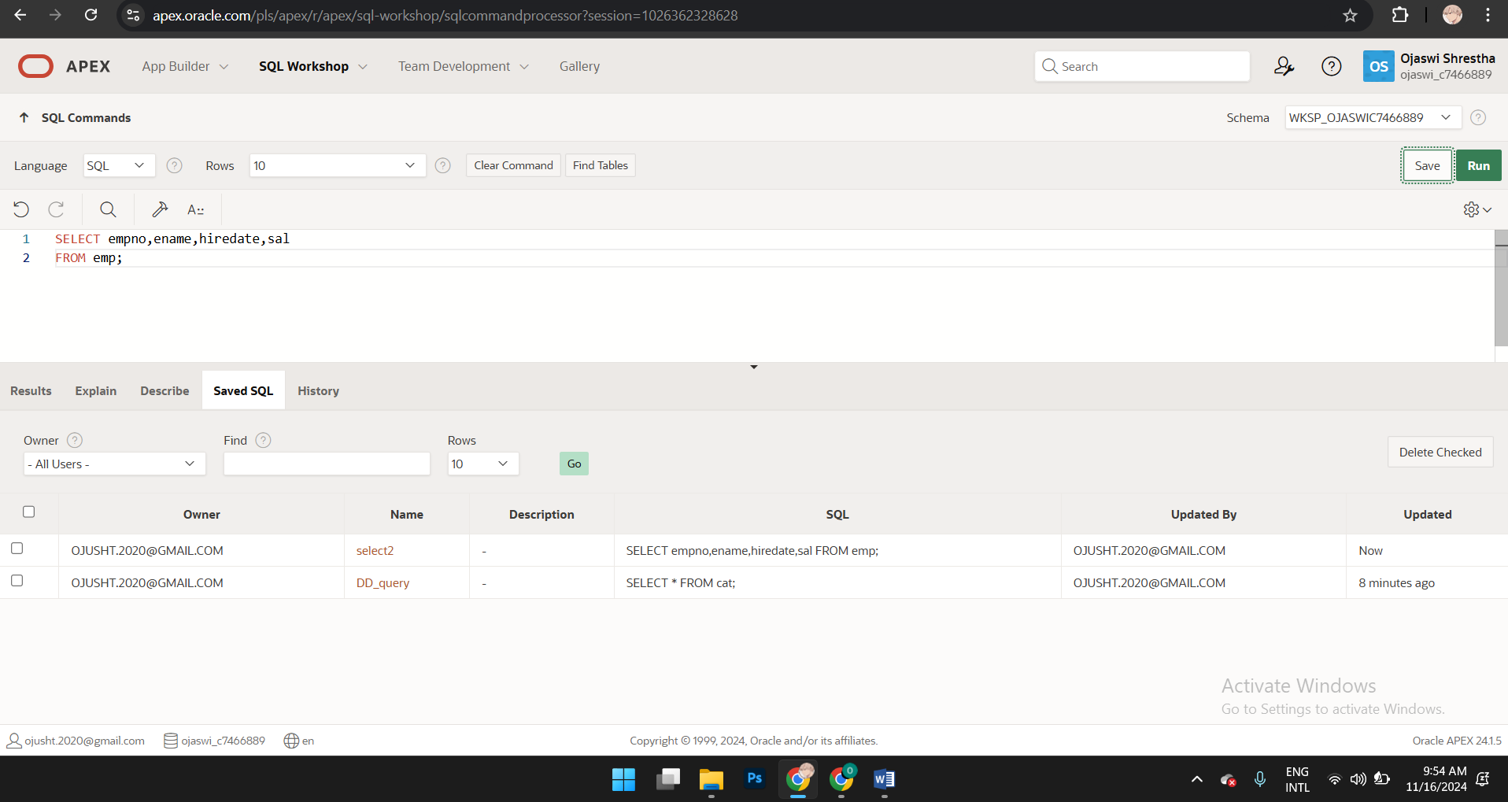

**Exercise 9** Write an SQL command to display all different job types. Tip: use emp tableRun the command and check the results. What different job types are there? Save your query as projection1.

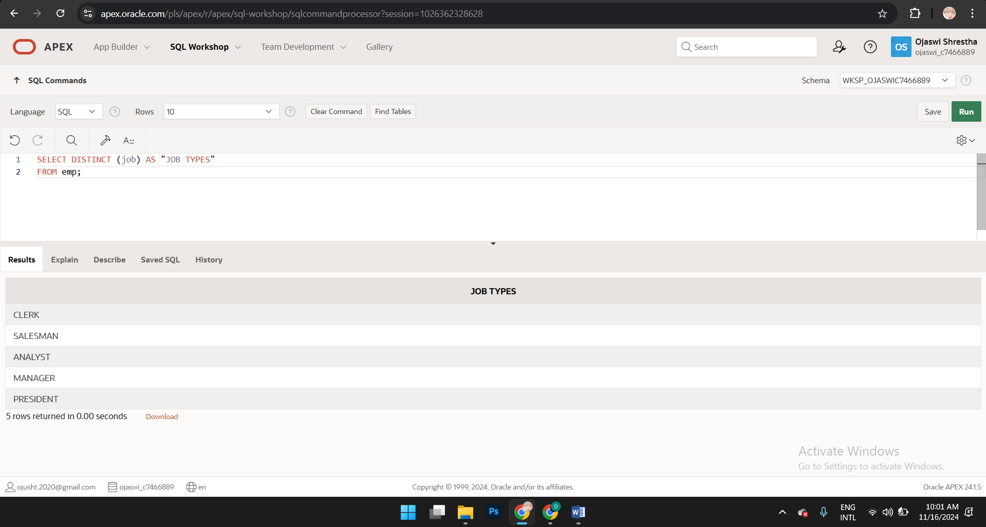

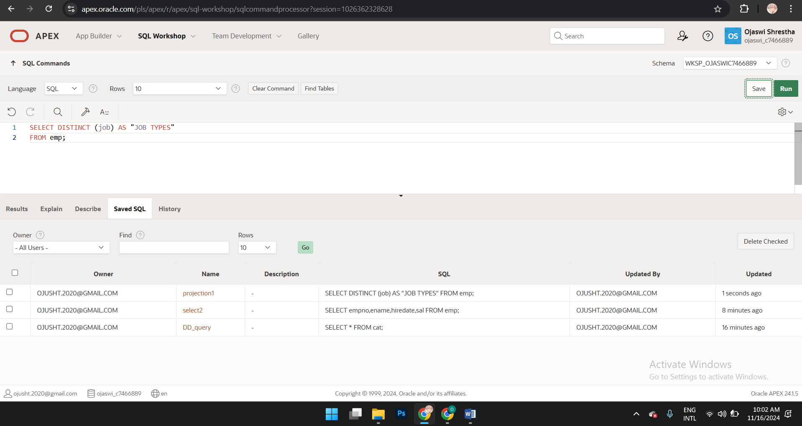

**Exercise 10**

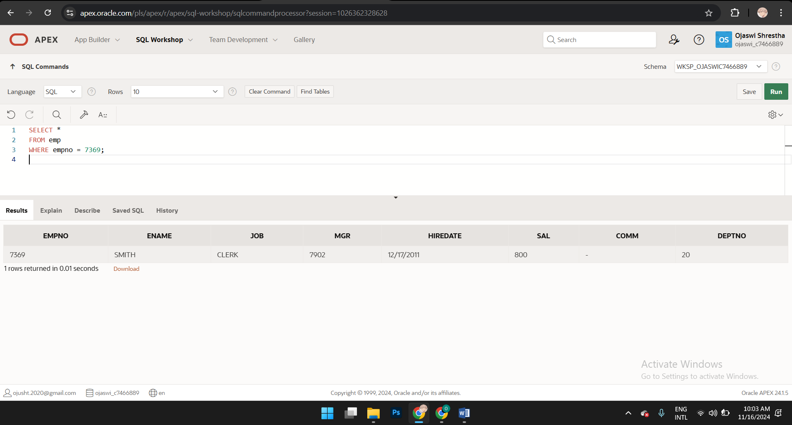

**Exercise 11**

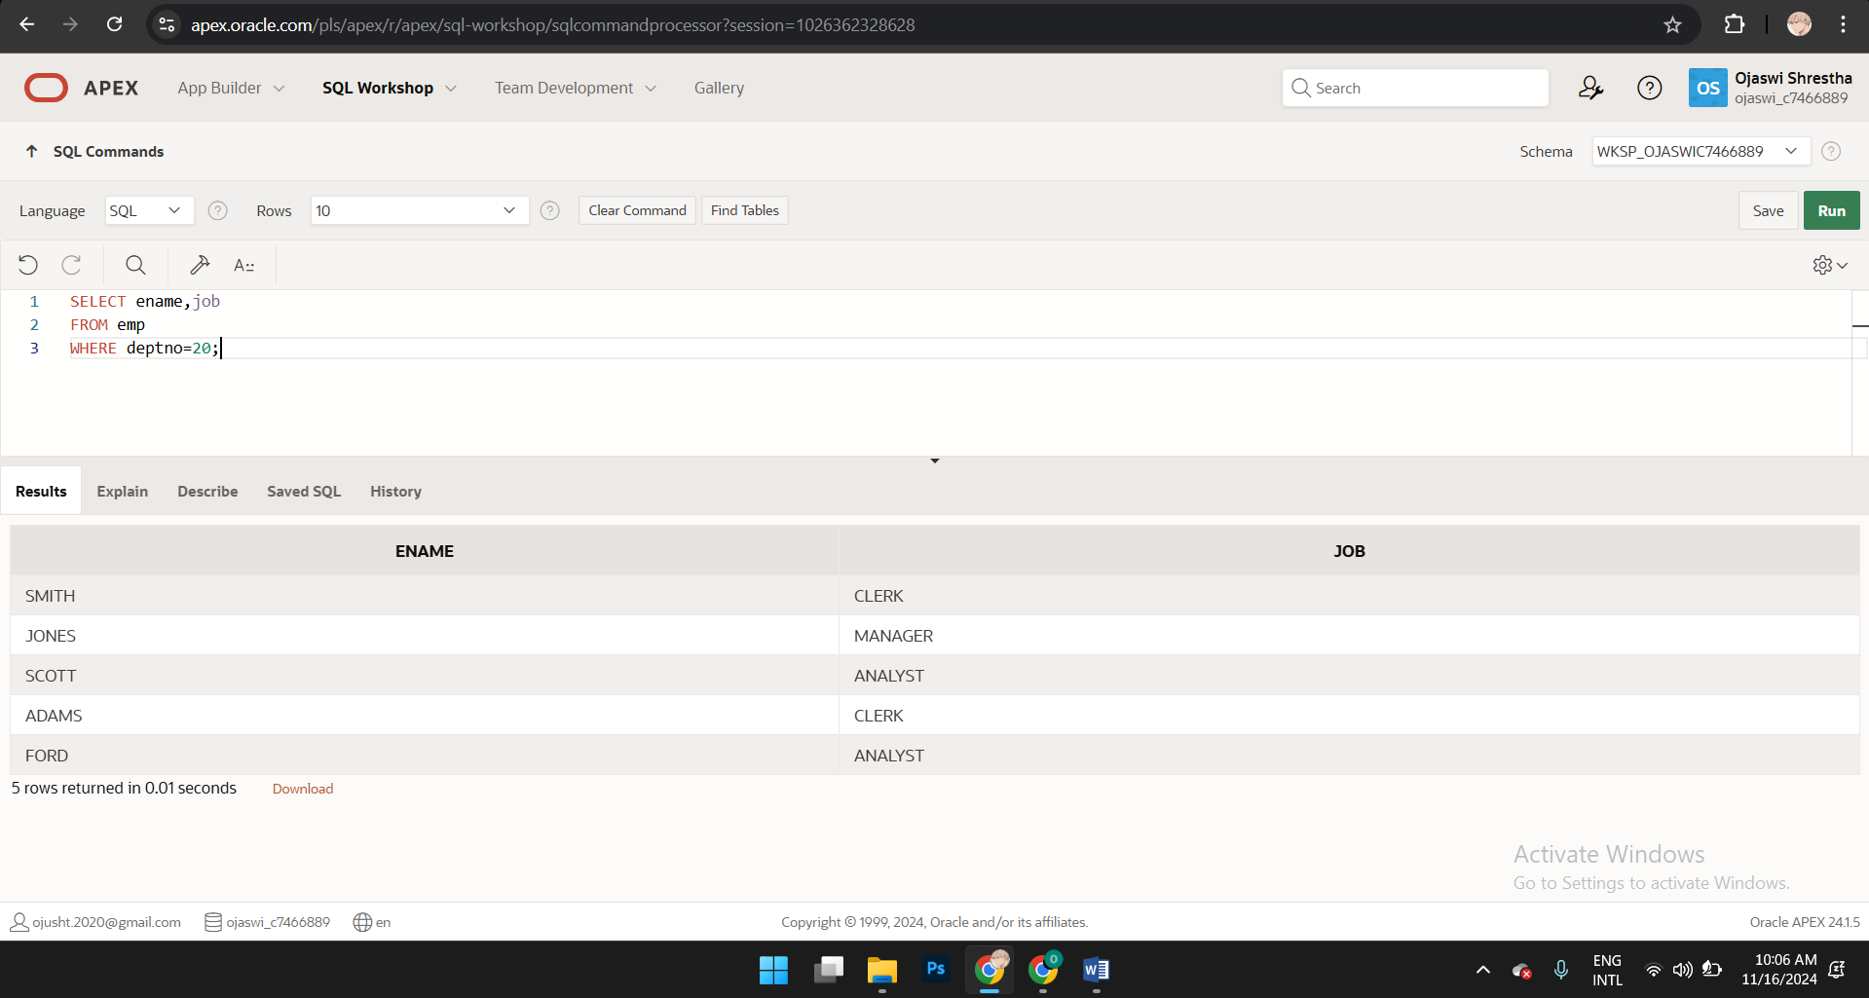

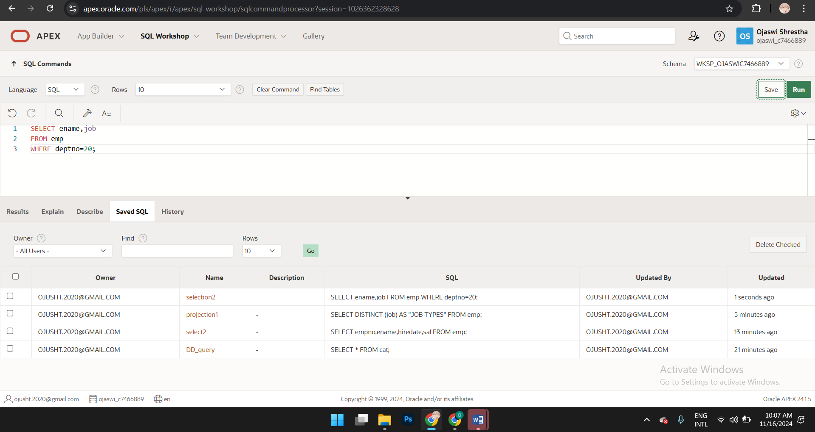

**Exercise 12: Challenge**

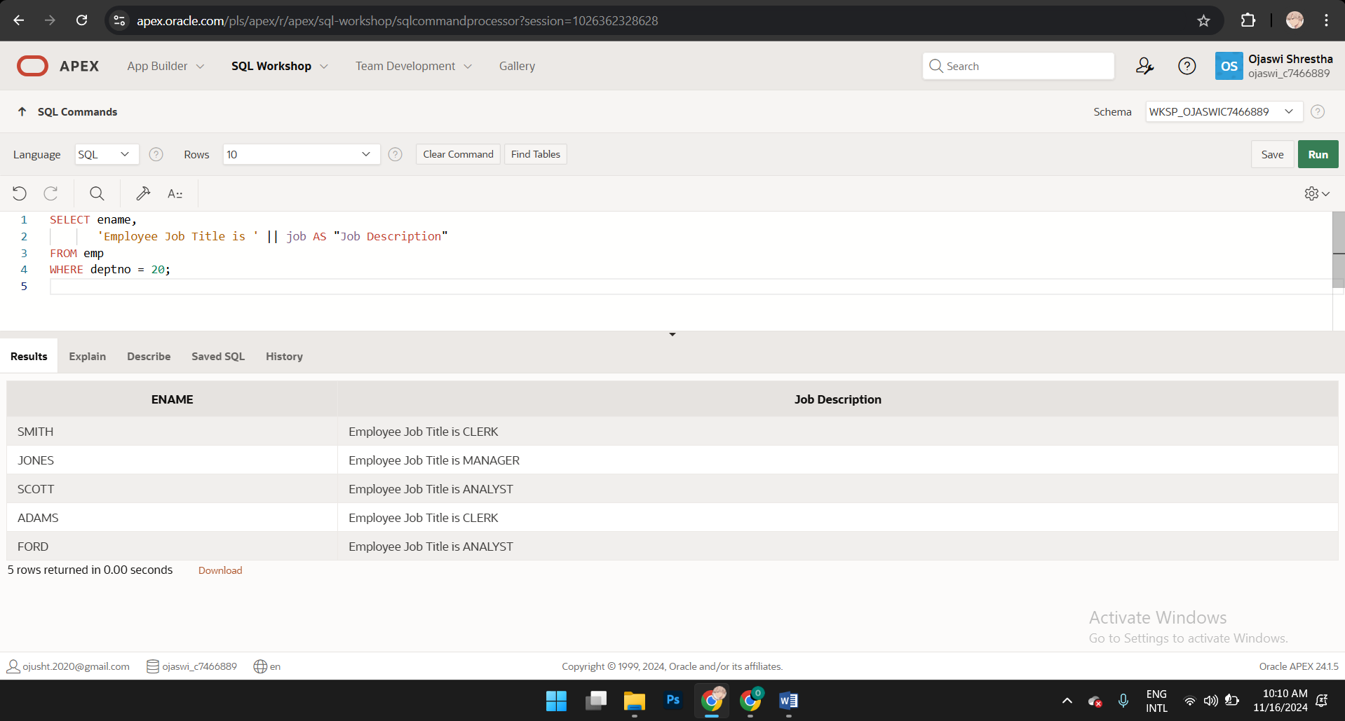

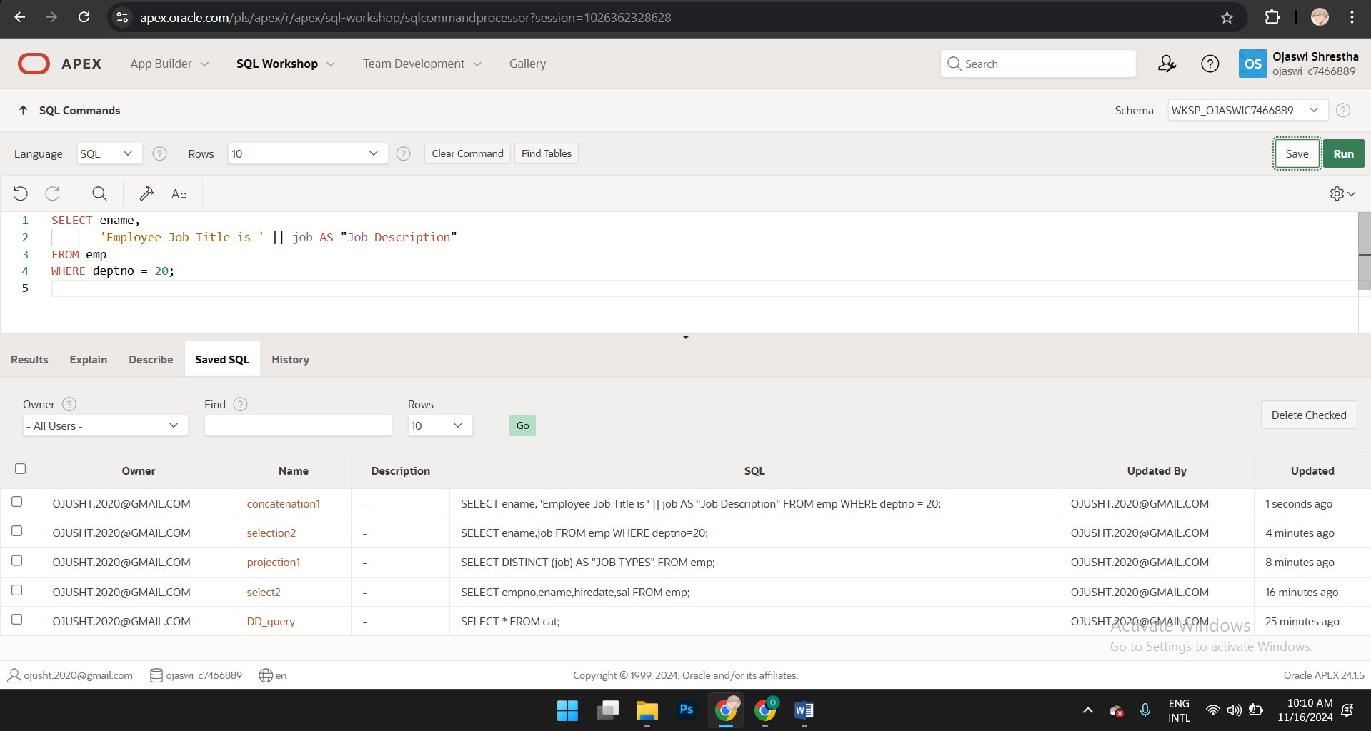

**Exercise 13**

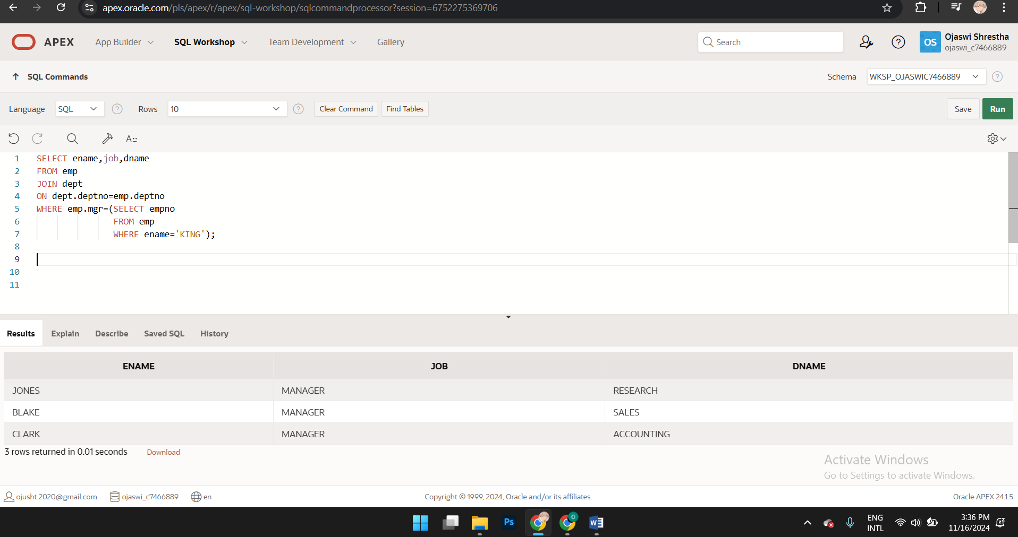

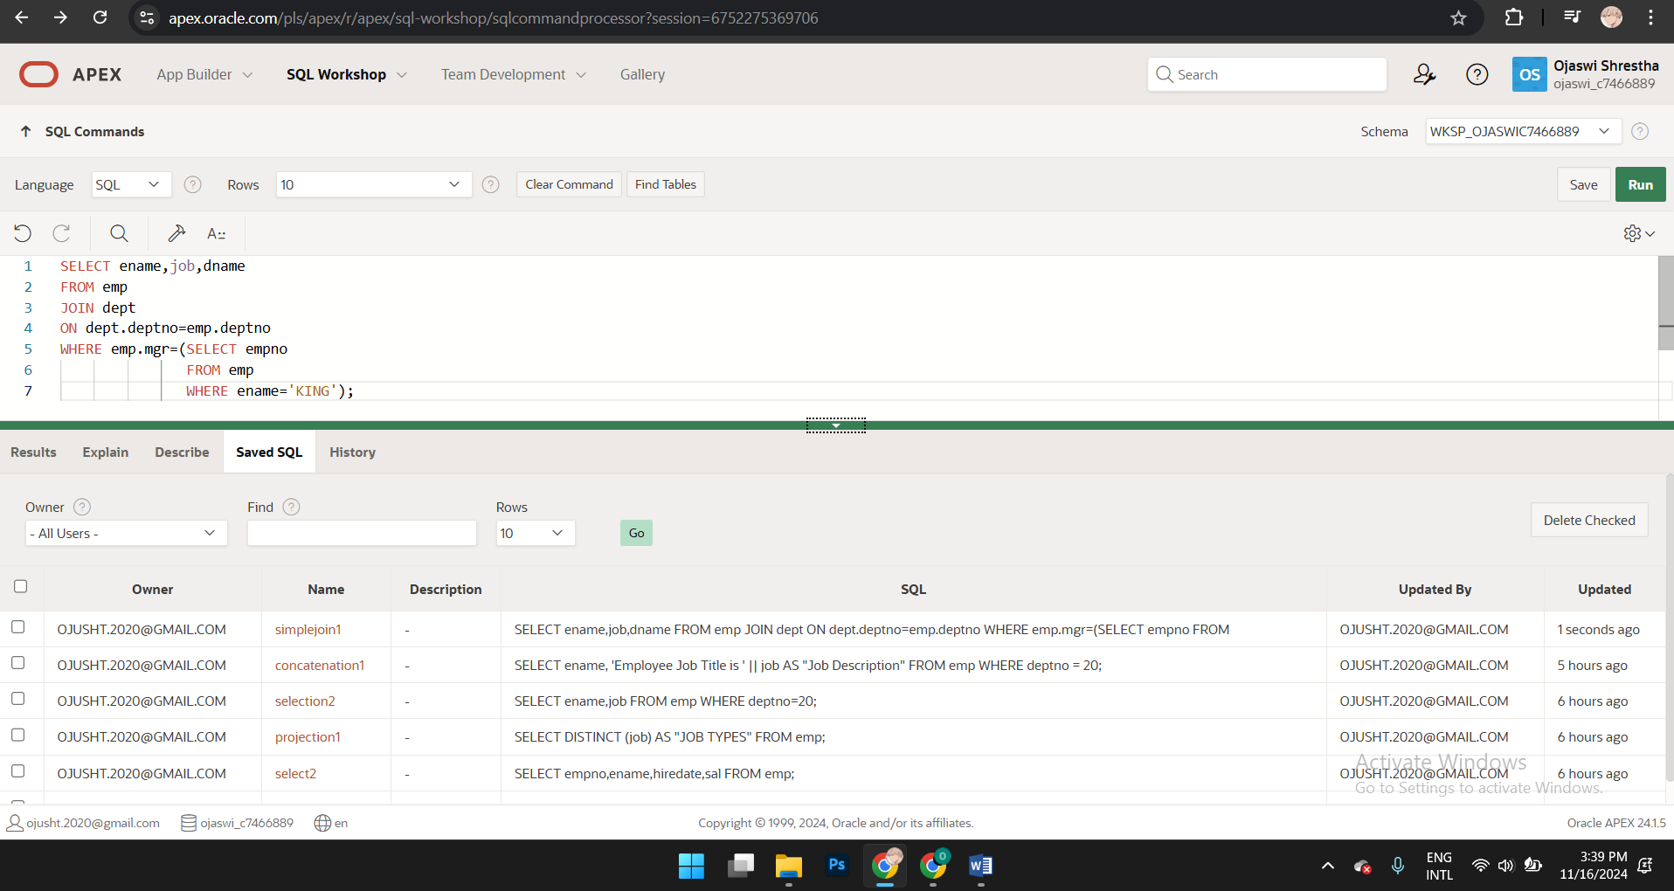

**Exercise 14** Show all employees working at location - **Dallas**. Run and Save your query as simplejoin2.sql

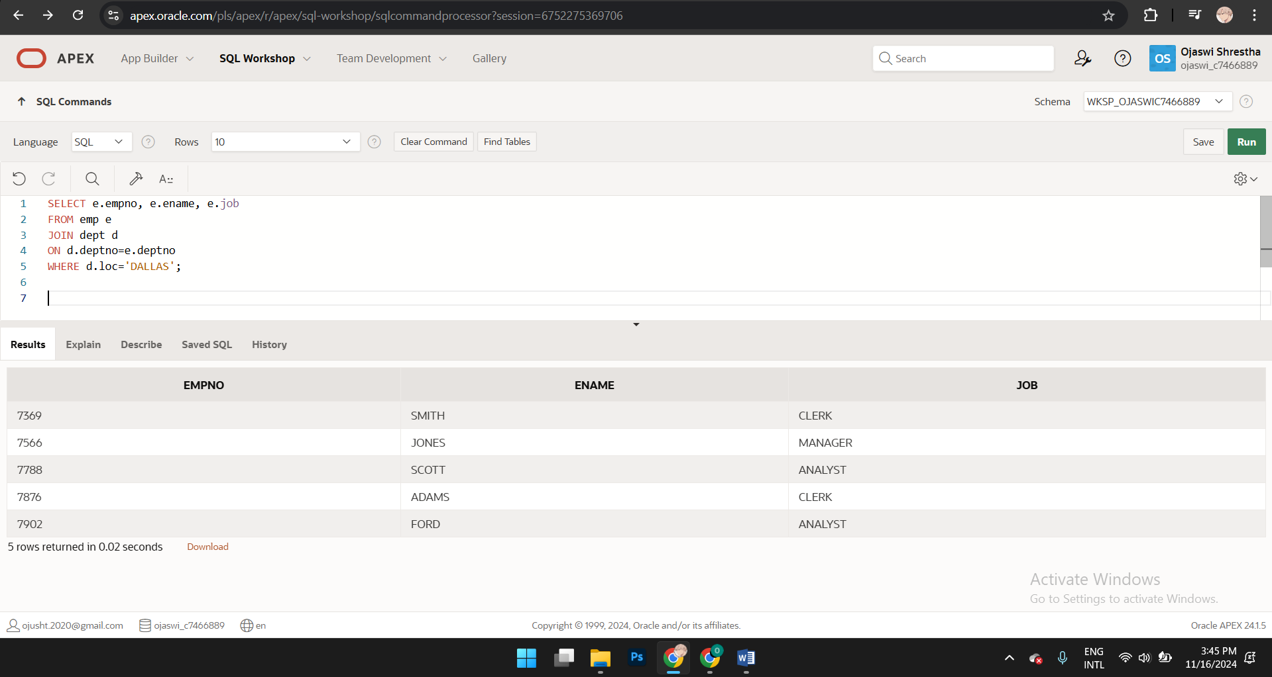

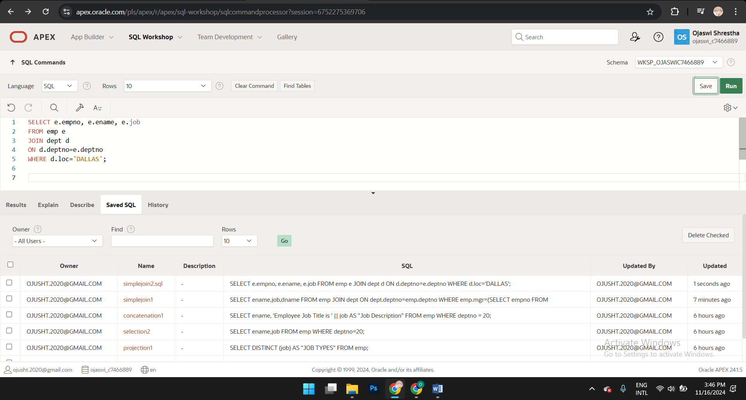

**Exercise 15** Modify your query 12 (concatenation1) and select also **empno** only for those that are managed by mgr **7839**. Run and Save this query as query15.

